SD – 01 Account Management
Purpose:
Allow travelers to securely register, authenticate, and manage access to their TravelMate accounts.
Main Flow:
The traveler selects either Register or Log In from the user interface. The Authentication Service validates the request against the database. If the request is valid, the system either creates a new account or authenticates the traveler and returns the result to the user interface for display.
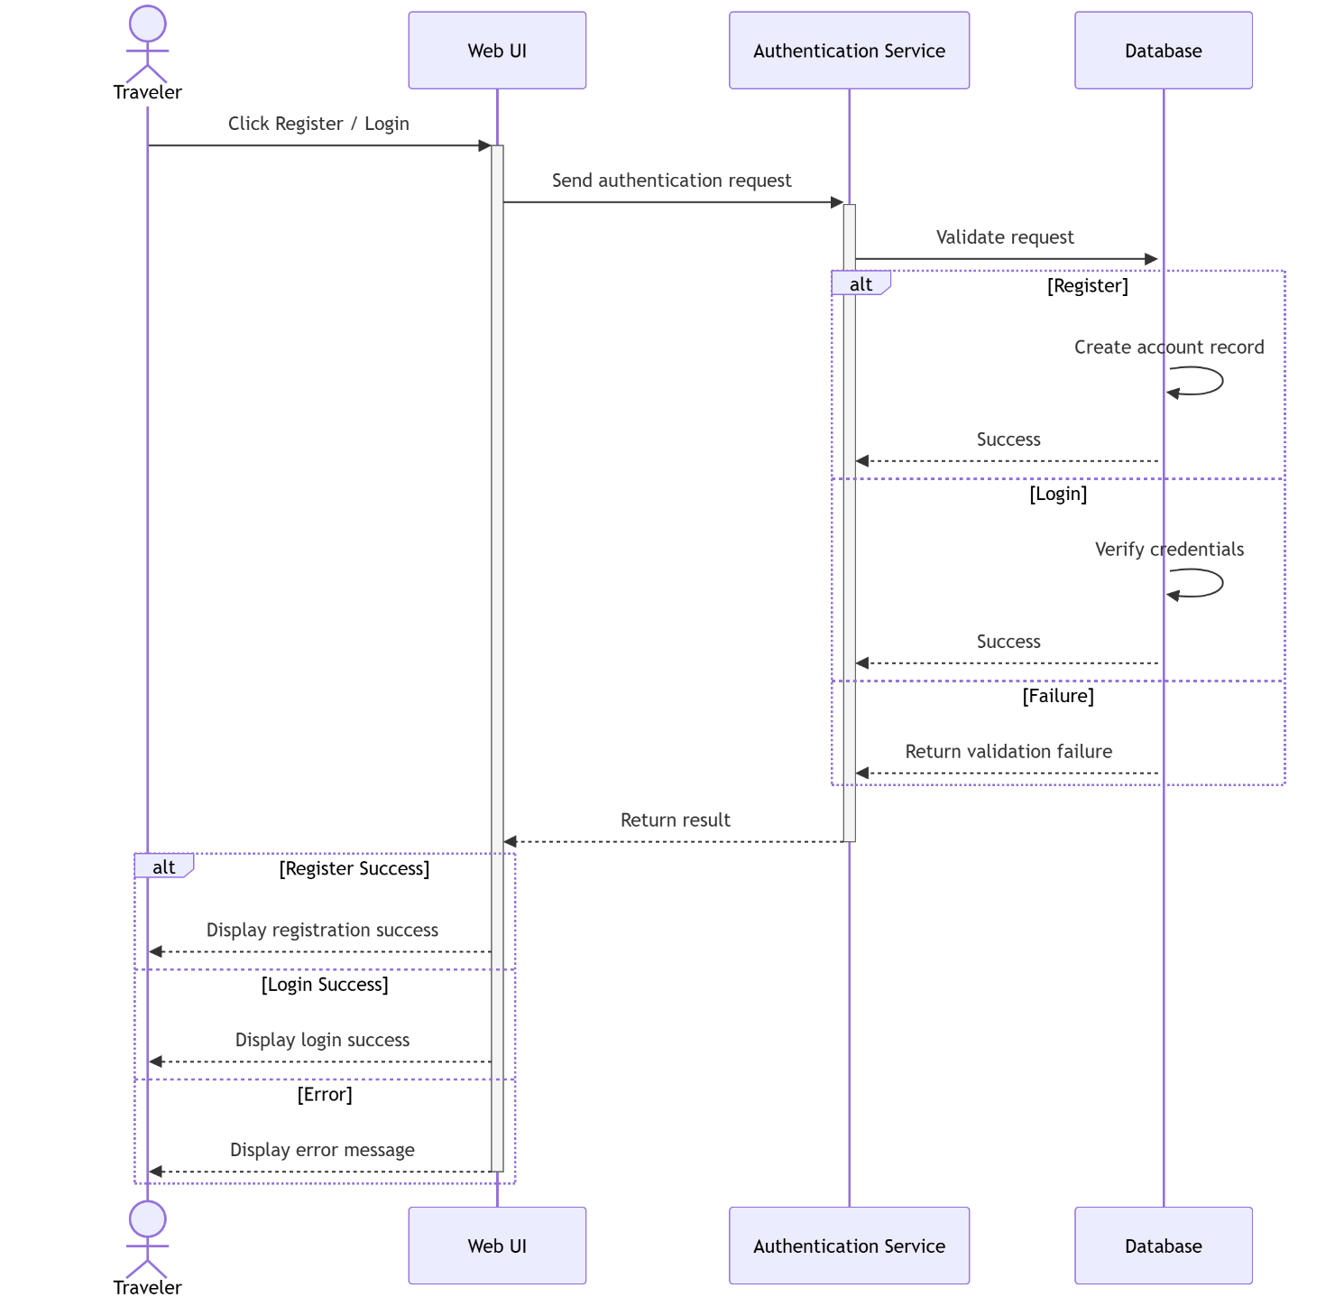

SD – 02 Trip Management
Purpose:
Allow travelers to create, update, organize, archive, restore, and delete trips throughout the trip lifecycle.
Main Flow:
The traveler selects a trip management action from the Trip List. The Web UI sends the request to the Trip Service, which validates the request and performs the requested operation through the database. The system then returns the processing result and updates the user interface.
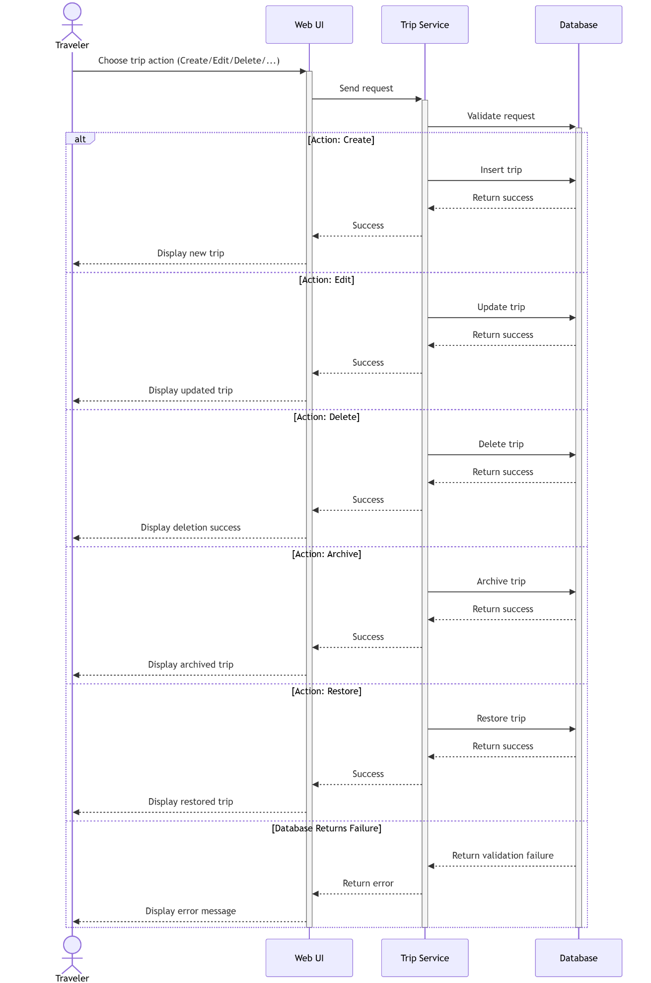

SD – 03 Collaboration
Purpose:
Allow trip owners to share trips, invite members, and manage collaboration through role-based access.
Main Flow:
The owner enables collaboration for a trip and invites members by email. The Collaboration Service validates the request, stores invitation data, and requests the Email Service to send invitations. Invited members can accept or decline the invitation, after which the system updates the collaboration status and notifies relevant users.
